DSAR Context-Aware Data Minimization PROTOTYPE – UAT
09-10-2026 & 15-10-2026
- DSAR Request Processing – RIGHT - DONE
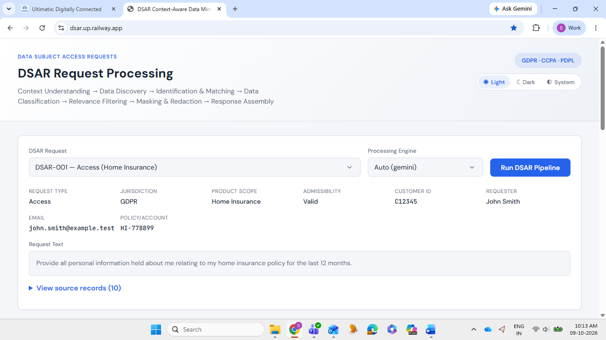

- GDPR/CCPA/PDPL – Can be shown as a drop-down list – NOT DONE

- DSAR Request - Remove Admissibility from here – NOT DONE
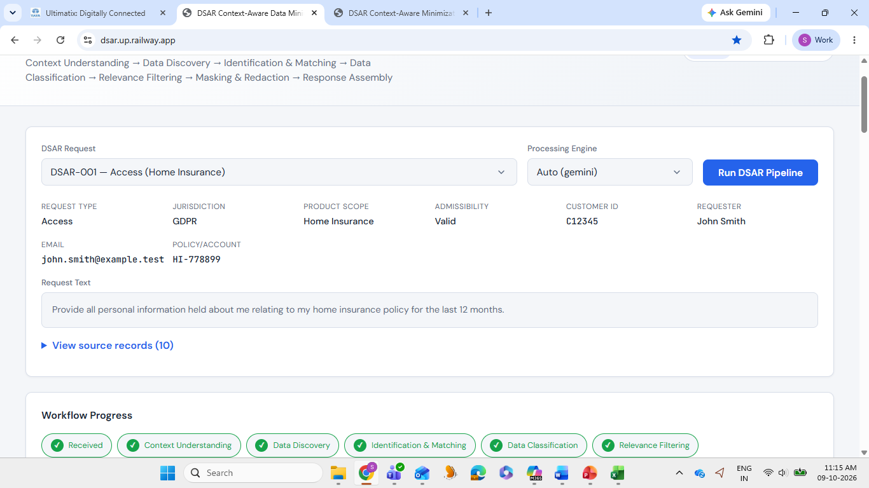

- DSAR Request – The dropdown should have Access, Portability, Erasure, Restriction/Objection - DONE
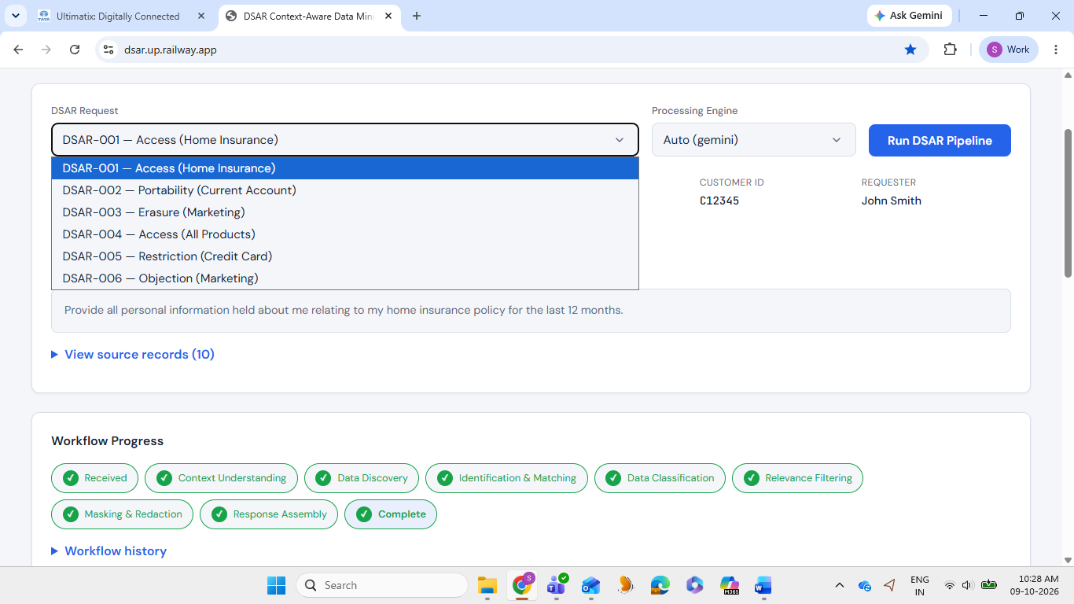

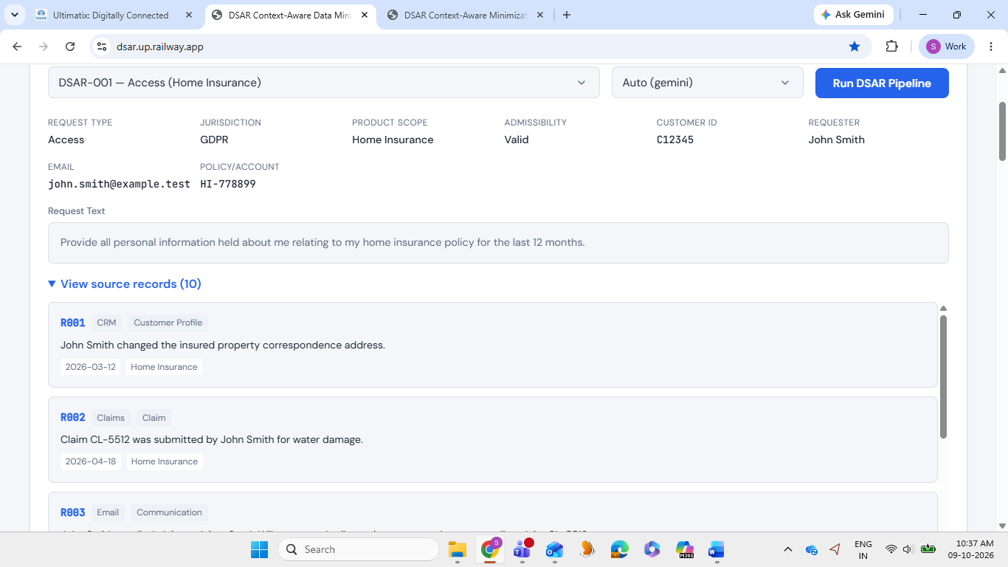
- View Source Records – To be removed. As it comes only later in the workflow in Data Discovery – NOT DONE

- Workflow Progress – Right - DONE
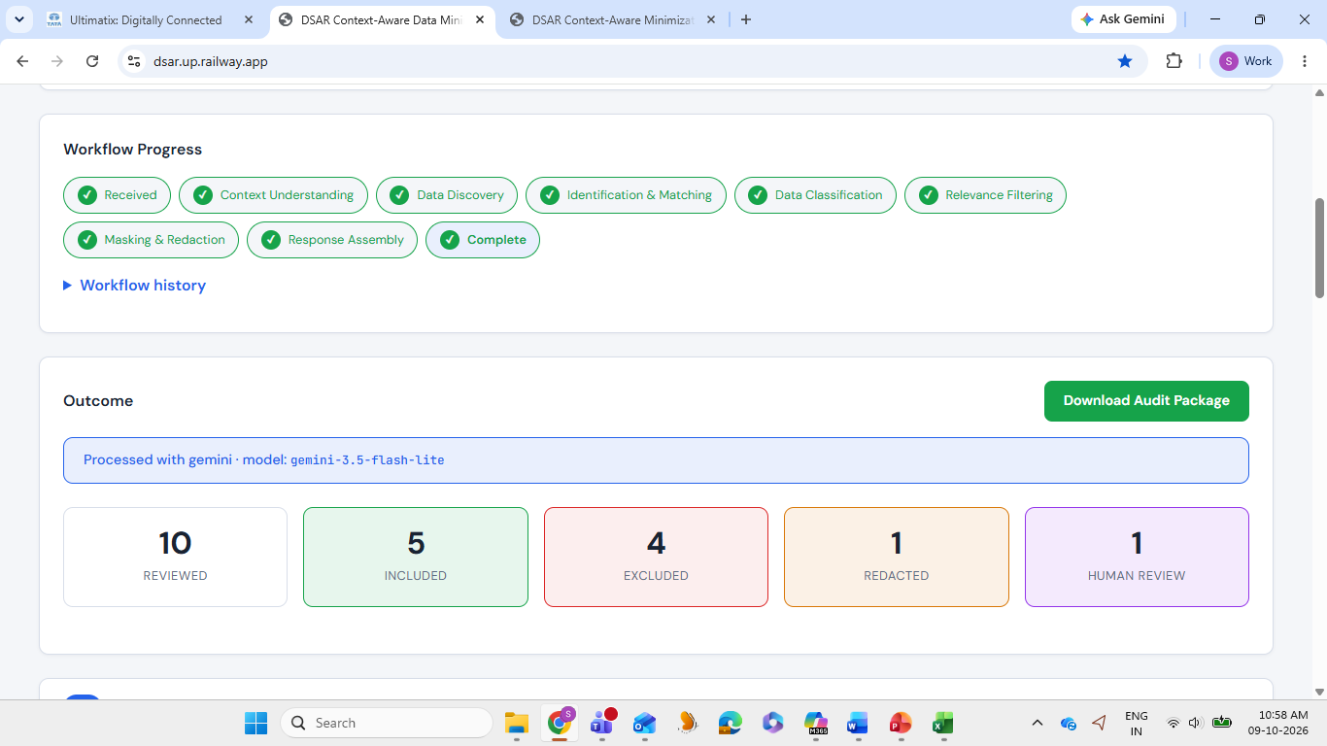

- Workflow History – Literature correction for each subhead – NOT DONE
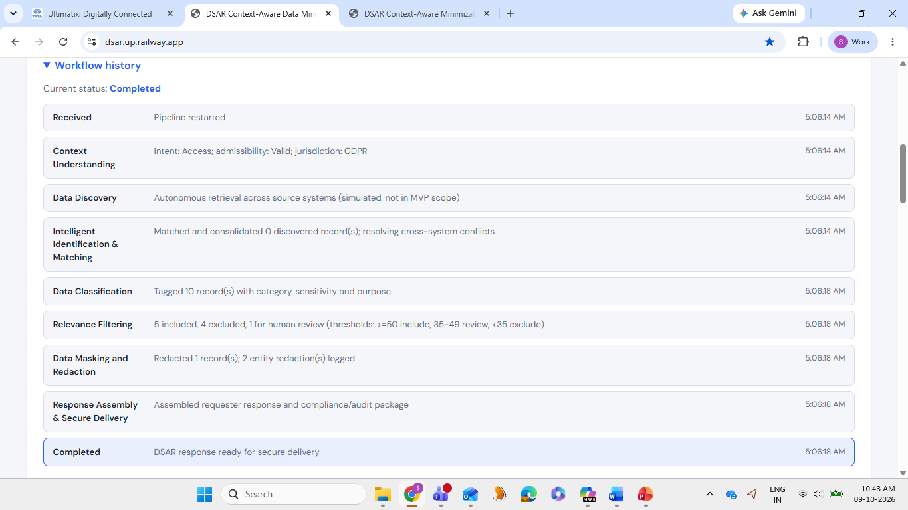

Received | DSAR Request received from Mr. John Smith
Context Understanding | Understand the request context, scope, jurisdiction, and legal validity
Data Discovery & Autonomous Retrieval | Identify and retrieve relevant data from distributed sources for DSAR fulfilment
Intelligent Identification & Matching | Correlate and consolidate related records to create a unified data view
Data Classification | Classify retrieved data based on privacy, sensitivity, ownership, and disclosure requirements
Relevance Filtering | Filter out non-essential information
Data Masking & Redaction | Protect third-party and sensitive information through automated masking and redaction
Response Assembly & Secure Delivery | Generate a response package to be delivered securely to the requester and Audit trial package
Completed | DSAR Request Response is ready for delivery

- Outcome – Move the download button below the result boxes – NOT DONE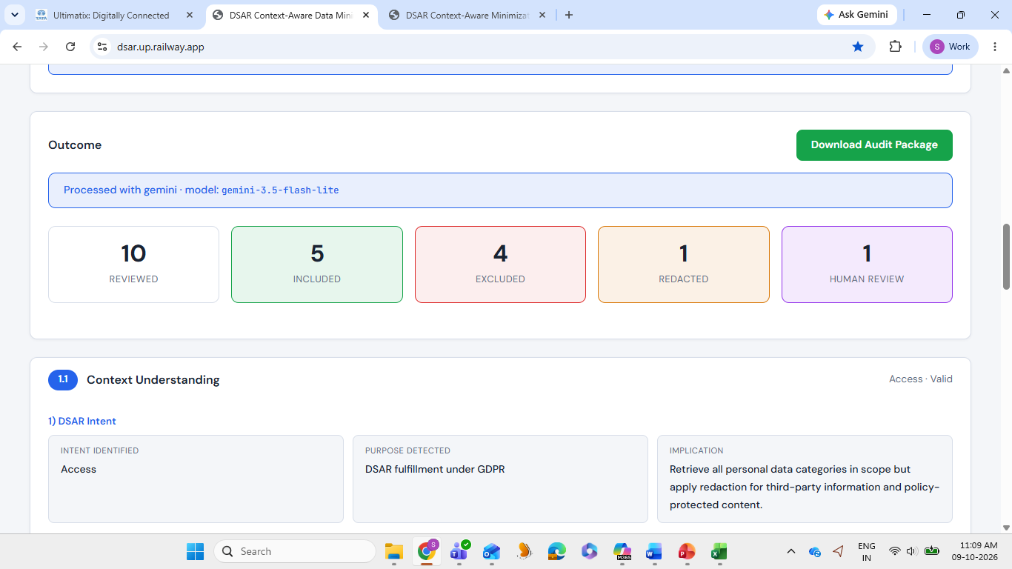

- Outcome – Have the following boxes with this data displayed – NOT DONE
Outcome Boxes | Logic | Example Output Display
Context | Dsar Request Type, Admissible / Non-Admissible, Jurisdiction | Access, Admissible, GDPR
Data Discovered | Total Number of relevant records retrieved | 25
Data Included | Total Number of relevant records selected for further processing | 20
Data Excluded | Total Number of non-relevant records rejected | 5
Redacted | Total number of masking /redactions done | 3
Human Review | Total Number of data sent for human review | 1

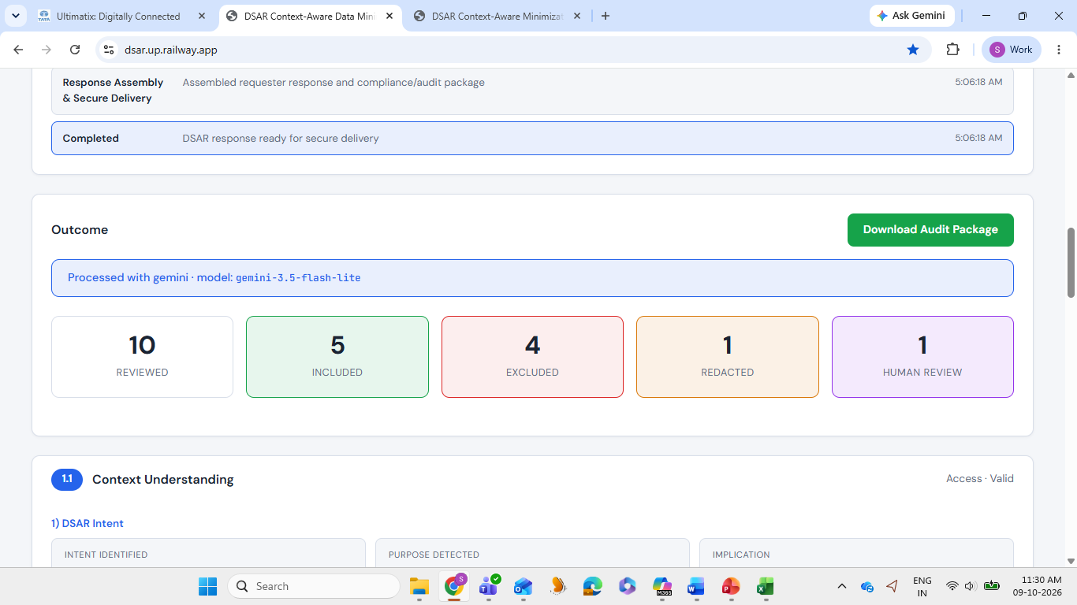

- Outcome – Two buttons are required. On clicking these, report has to be generated. (Sample has been shared) - DONE
Button 1 – “Requester Response” – Sample shared
Button 2 – “Audit Log” – Sample shared

- Workflow process- Each in detail – NOT DONE
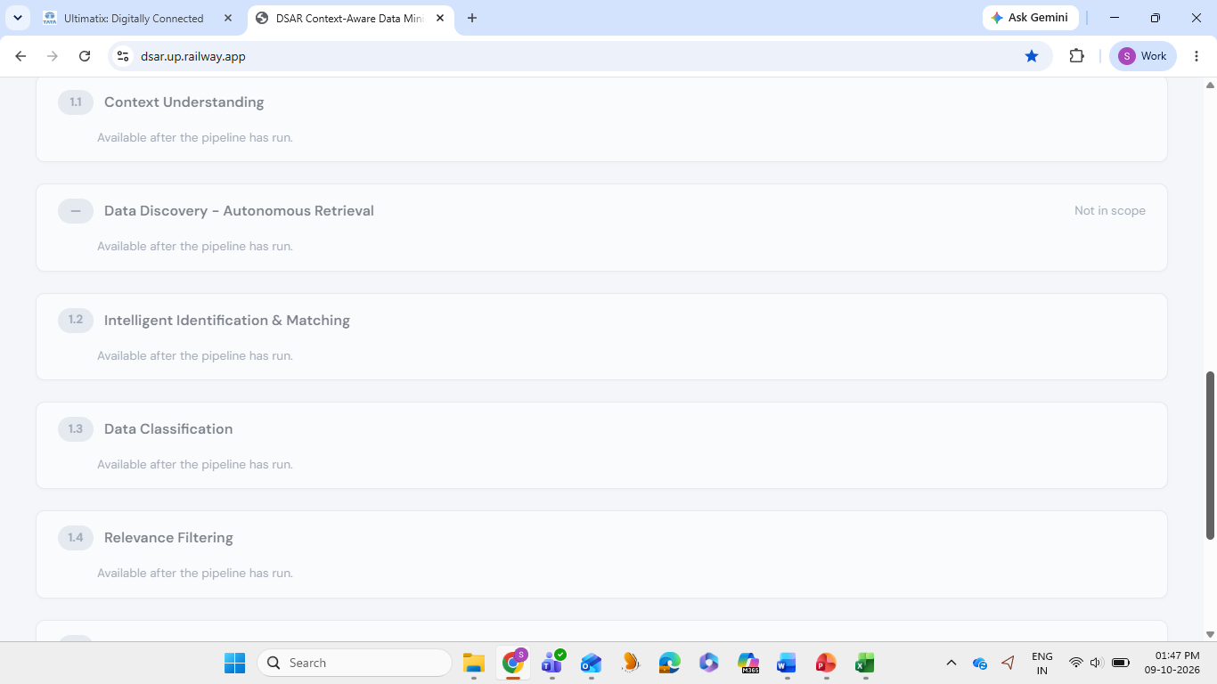

Context Understanding (Have only the below data, remove the rest)
S.No. | Process | Field | Sample Data
1 | DSAR Intent | Intent Identified | Access
2 | DSAR Category Classification | DSAR Type | Access
3 | DSAR Scope | Timeframe | 2025-09-07 to 2026-09-07
3 | DSAR Scope | Product / Service | Home Insurance
3 | DSAR Scope | Relationship Type | Policyholder
3 | DSAR Scope | Data Sources | CRM, Claims, Claims Archive, Email, Fraud Analytics, IT Monitoring, Motor Policy, Policy Admin
4 | Admissibility of Request | Admissible | Valid
5 | Applicable Regulatory / Juristic Laws | Regulation | GDPR
5 | Applicable Regulatory / Juristic Laws | Provision | Article 15 - Right to Access
5 | Applicable Regulatory / Juristic Laws | Response Deadline | 20 days
Data Discovery (Have only the below data, remove the rest)
S.No. | Process | Field | Sample Data
1 | Systems Queried |  | 20
2 | Relevant Data Discovered |  | 15
3 | Agent-to-Agent Retrieval Trace |  | Same as present
Intelligent Identification & Matching (Have only the below data, remove the rest)
S.No. | Process | Field | Sample Data
1 | Identify & Check | Record ID, Percentage of Compliance, Data belong to Data Subject | R001 - 100% - Yes  R002 - 0% - No
2 | Matching & Conflict Resolution | Same as present | Same as present
Data Classification (Have only the below data, remove the rest)
1 | Data Classification | Record ID, Category, Sensitivity, Purpose used | Same as present
Relevance Filtering (Have only the below data, remove the rest)
1 | Relevance Filtering | Record ID, Final Decision, Reason | R001 - Included - Has the requested information  R002 - Excluded - Duplicate data for R001  R003 - Human Review - Restricted internal fraud content requires human review before disclosure.
Data Masking and Redaction (Have only the below data, remove the rest)
1 | Redaction & Mapping Logs | Same as present | Same as present
2 | Redacted & Masked Disclosure | Same as present | Same as present
Response Assembly & Secure Delivery (Have only the below data, remove the rest)
1 | Requester Summary Report | Please use the report format, shared through email
2 | Compliance / Audit Package (Internal) - Decision Trace | Please use the report format, shared through email

28=09=2026
- Workflow orchestration – Please update the process display under each of the stages for more clarity.

- DSAR request received -> Context understanding -> Data Discover -> Intelligent Identification & Matching -> Data Classification -> Relevance Filtering -> Data Masking and Redaction ->Response Assembly & Secure Delivery -> Final deliverable

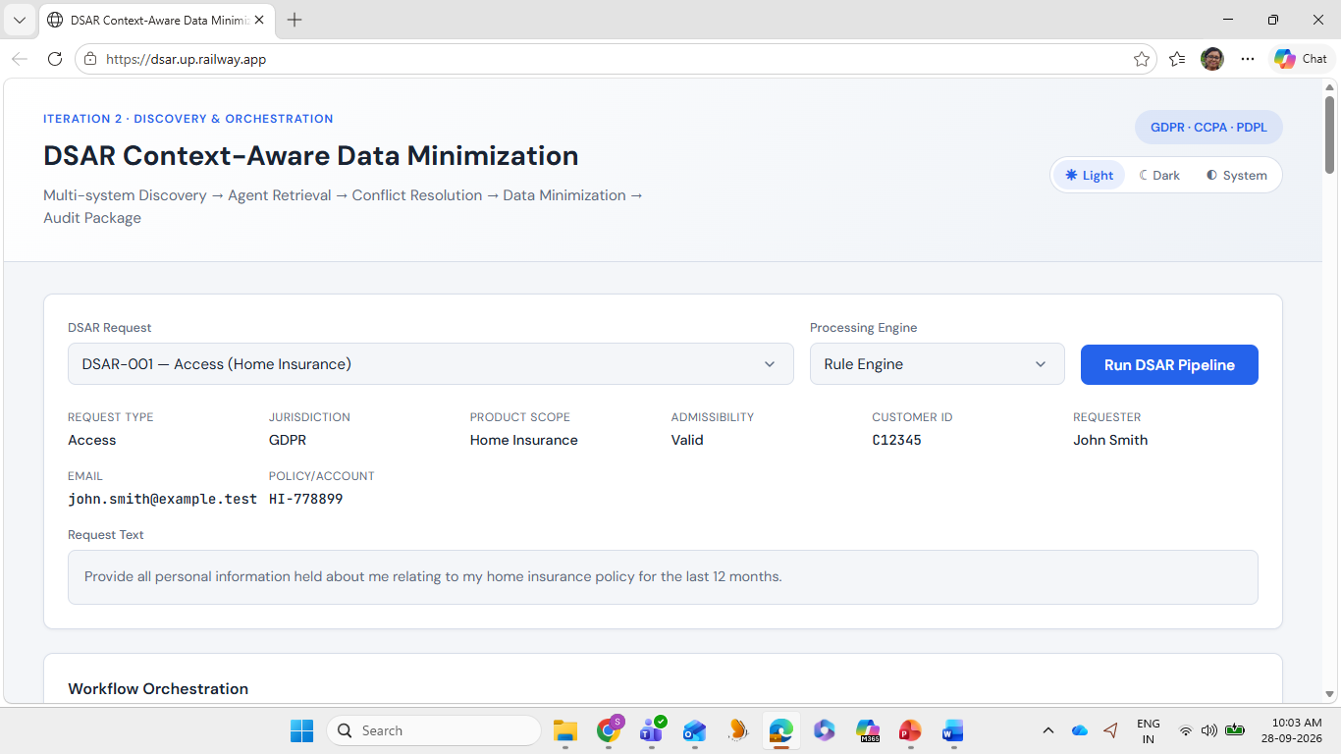

- DSAR request types – To be updated with : Access, Portability, Erasure, Restriction/Objection
- Deliverable required – one for audit and another for client reply.

